Interactive Visualization of Convolutional Neural Networks

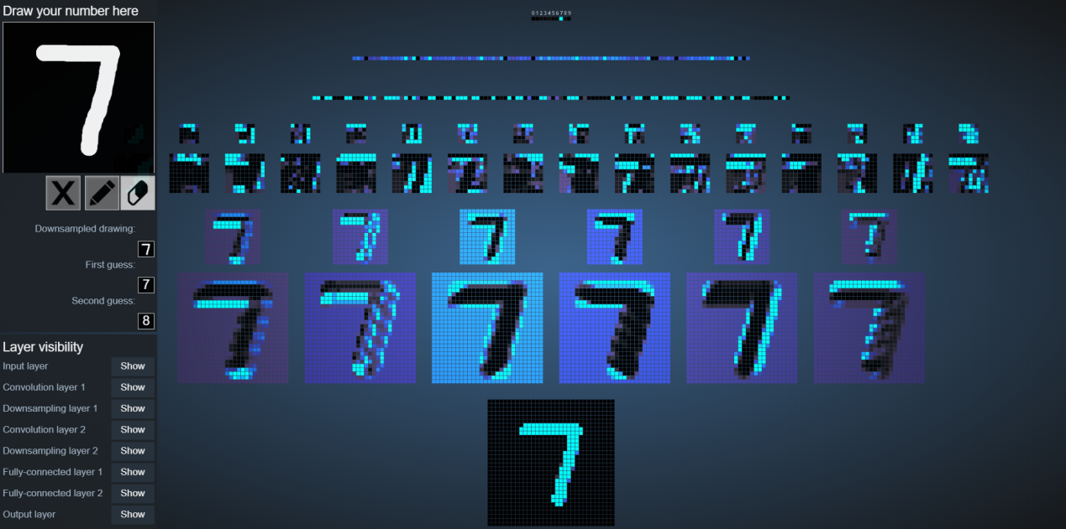

From: <https://www.cs.ryerson.ca/~aharley/vis/conv/flat.html>

The proposed visualization is an interactive diagram of a convolutional neural network trained to recognize handwritten digits. On the left is a drawing pad, where you can draw numbers for the network to classify. The activation level of each node is encoded in hue and brightness.

Go ahead and explore more about it [here](https://www.cs.ryerson.ca/~aharley/vis/conv/flat.html)